CSC40202
NEXA

UI/UX Design & System Architecture

# | Student Name | Student ID
1 | Ghaida Hashem AlQarni | 2240004359
2 | Fatimah emad alarfaj | 2240007580
3 | Heba Khaled Askar | 2240006064
4 | Munirah Hassan Albuainain | 2240007600
5 | Jawaher Shaya Hazazi | 2240006281

1. Application Architecture and Unidirectional Data Flow

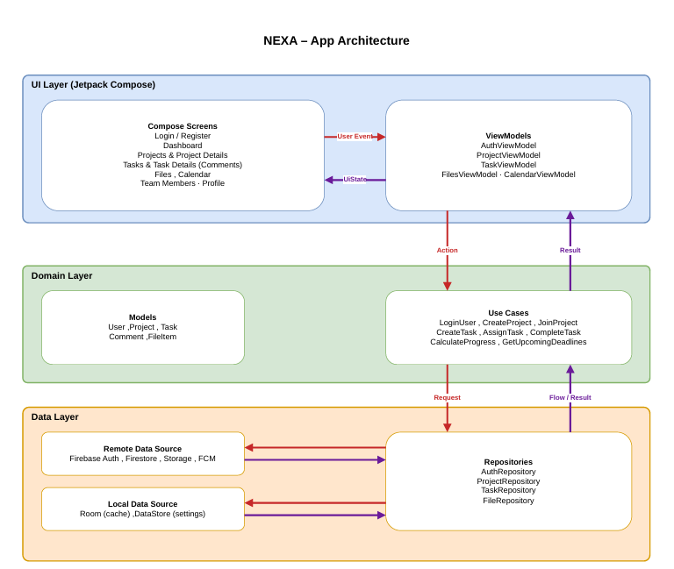

3. Navigation Map

2. UI/UX Design & App Wireframes

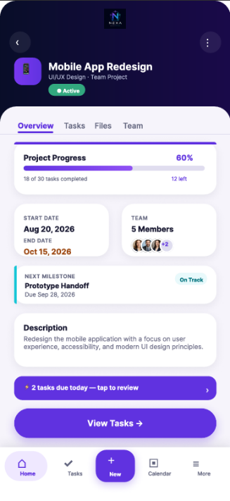
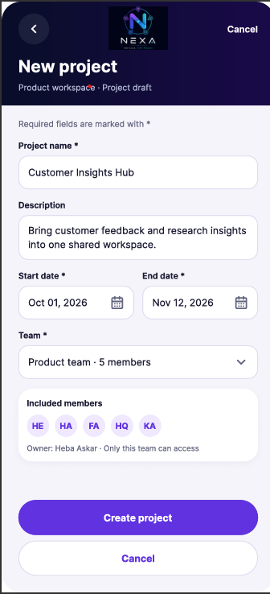
￼￼￼

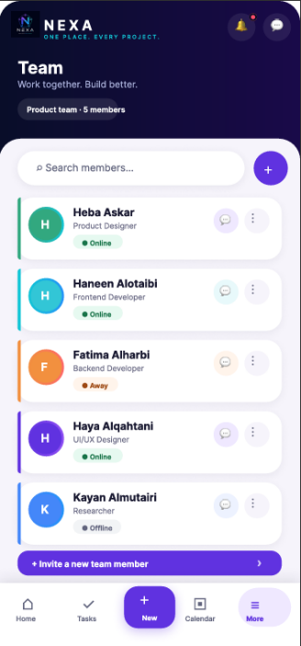
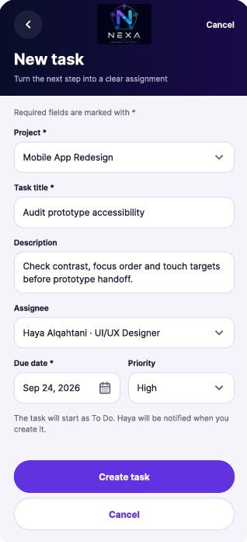
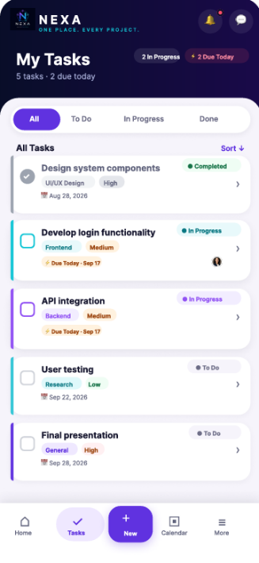
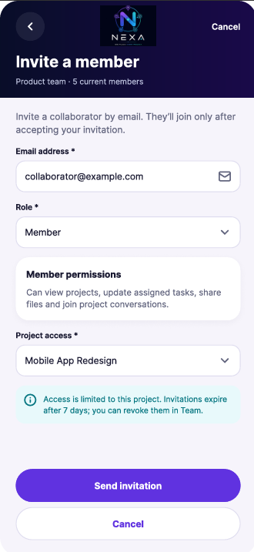

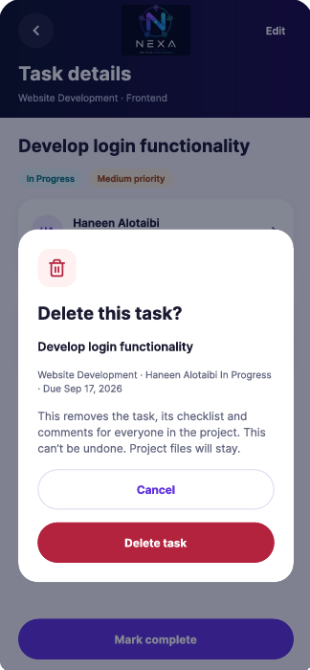
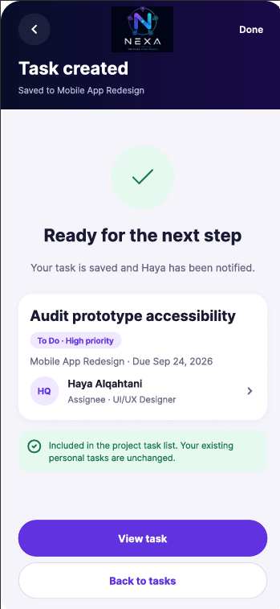
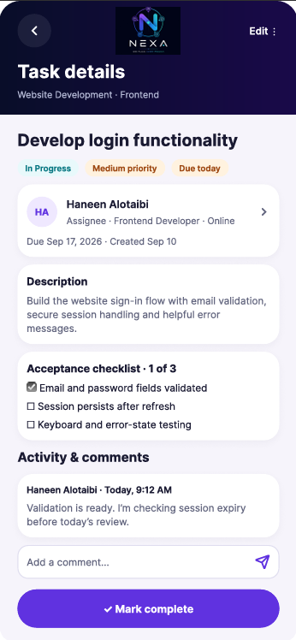
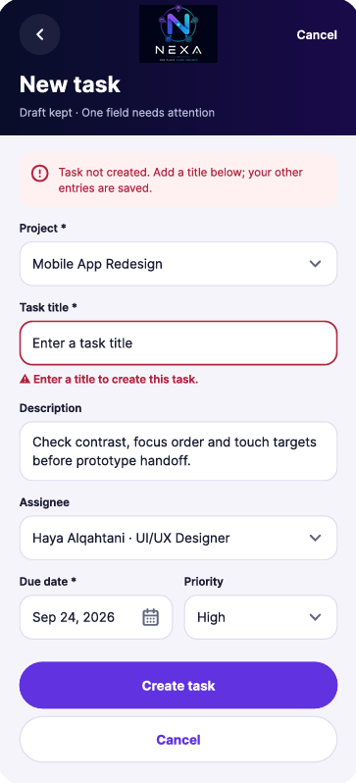

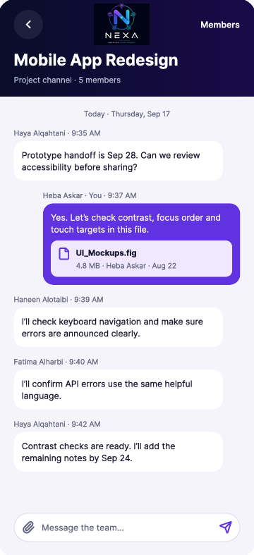

3. App Navigation Map

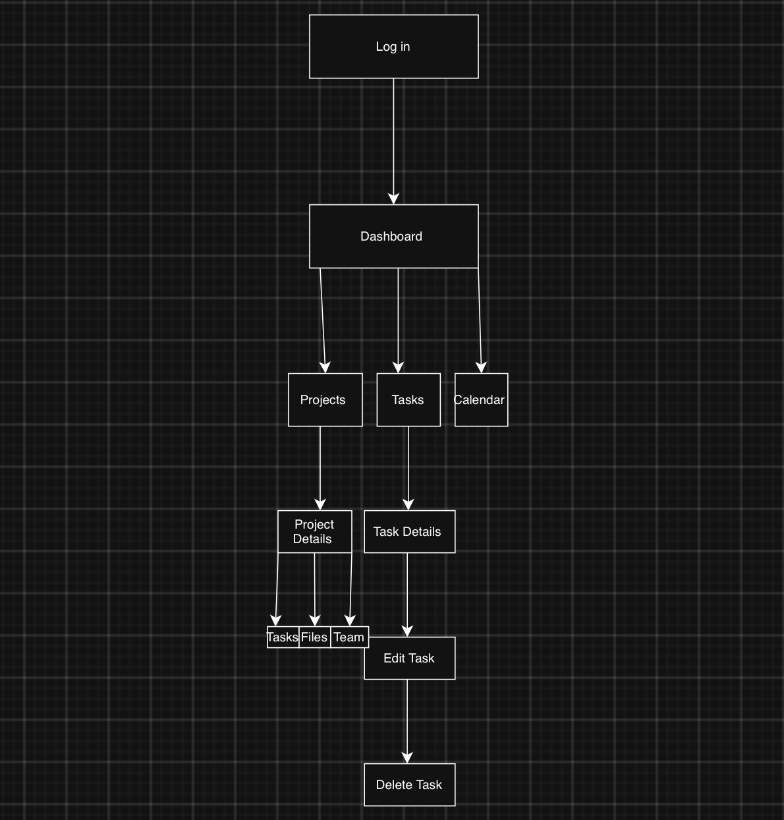

4. Jetpack Components and Libraries with Justification
NEXA will use the following Jetpack components and supporting libraries to implement its features. The selection aligns with the application’s UI, Domain, and Data layers and supports Unidirectional Data Flow (UDF).
Component / Library | Planned Use in NEXA | Justification
Jetpack Compose | Build screens such as Login, Dashboard, Projects, Tasks, and Team Members. | Enables reusable UI components and updates the interface when the observed application state changes.
ViewModel | Manage screen state and handle user actions through ViewModels such as AuthViewModel, ProjectViewModel, and TaskViewModel. | Separates screen logic from composables and retains UI state across configuration changes.
Room Database | Cache project and task data locally. | Supports structured local queries and access to previously cached data without an internet connection. Repositories will coordinate updates between Room and Firestore.
DataStore | Store local user settings and preferences. | Provides asynchronous persistence for small settings, keeping user preferences available between app launches.
Firebase Authentication | Support account registration, login, logout, and password reset. | Provides managed authentication without requiring the team to develop a custom password authentication service.
Cloud Firestore | Store shared projects, tasks, memberships, deadlines, and task comments. | Supports real-time data updates so team members can observe changes to tasks and project progress.
Cloud Storage for Firebase | Store and retrieve project documents and attachments. | Handles file contents separately from structured project data and supports access control through security rules.
Firebase Cloud Messaging (FCM) | Receive notifications about task assignments, updates, and deadlines. | Enables push notification delivery from a trusted backend. Deadline scheduling and notification triggers require separate backend logic.

